Please look at the words and pictures below, and we'd better improve the logic of our system.

- When there are multiple payments for an invoice, we can not view the details of payment date and multiple payment amounts in the report.
- If the invoice of a business occurs in June but the payment is in July, so when we use the Customer Payment Detail to filter the data in June, the payment amount we see in June should be 0, and the payment amount should be found when filtering the data in July, and the payment date and payment details should be displayed in July.
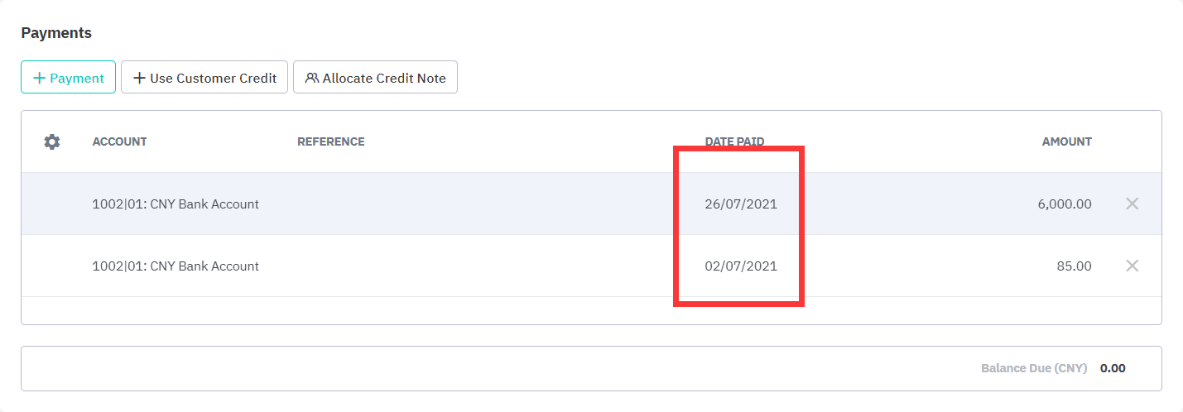
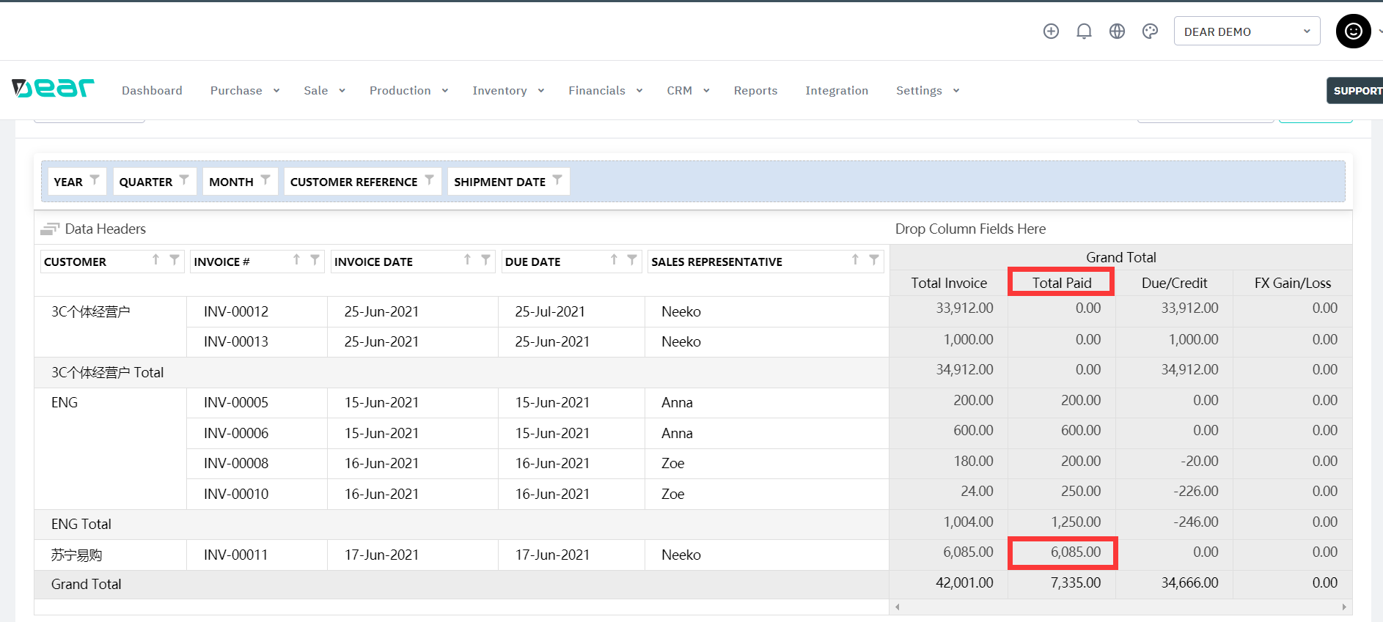
(This amount should be filtered out in July)

WE NEED THIS ANALYSIS REPORT FROM FINANCIAL POINT OF VIEW.
From a financial point of views, the logic of reports should be as follows：

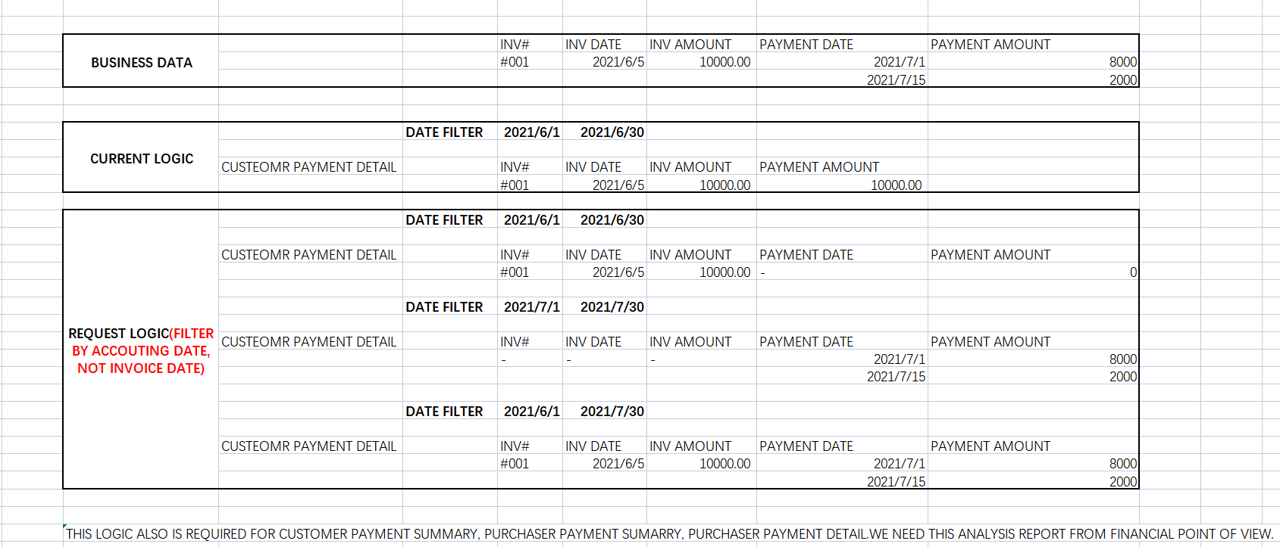
THIS LOGIC ALSO IS REQUIRED FOR CUSTOMER PAYMENT SUMMARY, PURCHASER PAYMENT SUMMARY, PURCHASER PAYMENT DETAIL.

Thanks

