Add Services into Quick sales in Dear POS application

Pre-Requisites: Create ‘service’ as a product
1. Method 1 : Listing products on Dear Application
1. The ‘Service’ item needs to be created in the Dear Application> Inventory> Product/screen.
2. The ‘Service’ item needs to be listed in the POS through Dear application > Integration> POS> Select store> Catalogue tab

2. Method 2 : Listing products on Dear POS Application
1. The ‘Service’ item needs to be created in the Dear POS Application> Inventory> Product screen.
2. Upon the selection of ‘Type(Service)’, the mandatory fields need to be filled in.

Method 1: Using Normal POS checkout
POS Application
1. Navigate to the POS link
2. Navigate to the Sell> Register in the Dear POS menu. Search for the listed ‘service’ name. DEAR POS application begins searching for the service as soon as the user begins typing into the Search bar. The listed set of service items needs to be included for the users to search.
3. Click the service from the search list to add it to the right-hand side of the POS checkout screen.
4. It should be possible to change the quantity, price, product discount of the ‘Service’ by clicking the Quantity box and Price box. When the user clicks on the related boxes, a calculator mode will appear to change the quantity/price/product discount.

Note :
It is the same as the current POS – product quantity/price/product discount changing mechanism.

5. Pay – Click the ‘Pay’ button to make the payment at the bottom of the POS checkout screen. The click of this button will navigate the screen to decide on the payment mode - by cash or credit card. There will be 2 payment methods :
- Cash
- Credit card
Add a new/existing customer to use the below additional options :
- Layby
- On Account
- Store credit

Note :
- It is the same as the current payment methods for product sale as the above mentioned payment types.

6. Tax - Edit the tax figure by clicking the Tax box. This button is just found above the ‘Pay’ button in the POS checkout screen.
7. Discard - Sale is deleted from the system and can no longer be retrieved. This button is just found above the ‘Pay’ button in the POS checkout screen. On confirmation message, click ‘clear sale’ to clear the sale from the system.
8. Park - Parked sales can be retrieved and edited for later use. This button is just found above the ‘Pay’ button in the POS checkout screen. On confirmation message, insert ‘park sale reasons’ to park the sale for later use.

Note : To retrieve a parked sale, click Sell> Parked Sales in the DEAR POS menu.

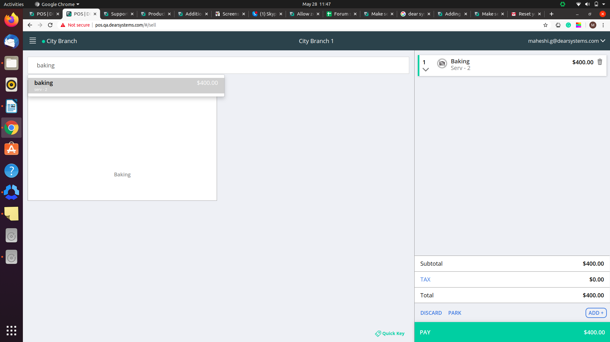

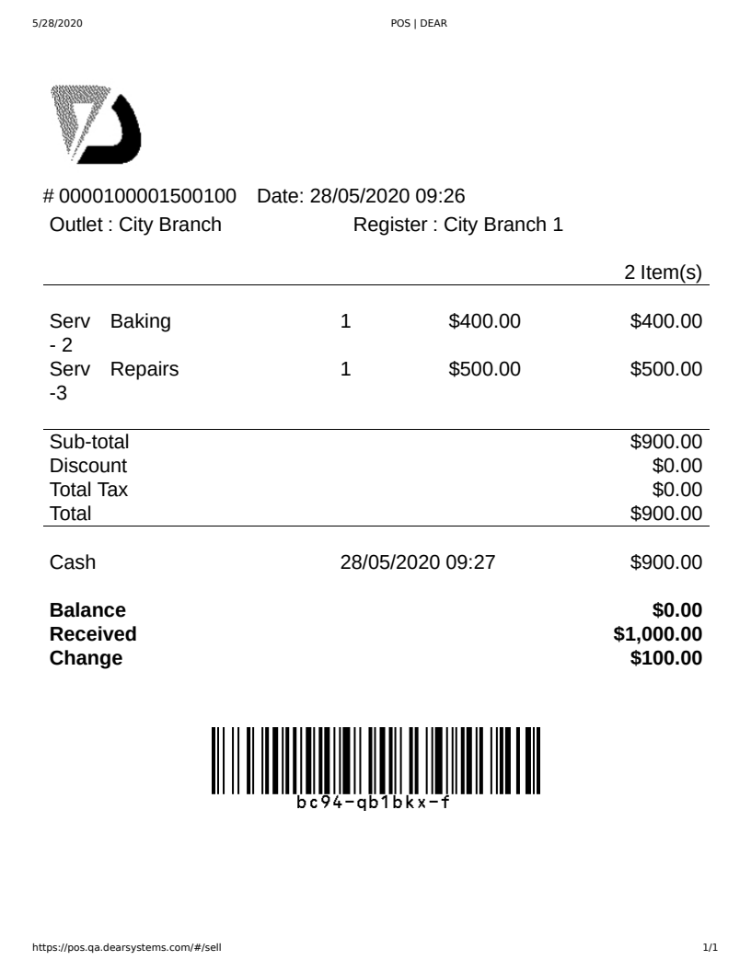

Method 2: Using POS Quick Sales

POS Application
1. Follow the points : 1,2,3,4 in Method 1
2. Select ‘Add’ button which can be found just above the Pay button in the POS checkout screen, then click Quick Sale.
3. On the Add Quick Sale window, enter the service name, quantity, and price, then click the Add button on the top right to close the window. Once, added back on the POS Cash Register page, the quick service sale's details are now displayed.
4. Follow the points : 5,6,7,8 in Method 1

