Dear Inventory System
Manual of Procedures

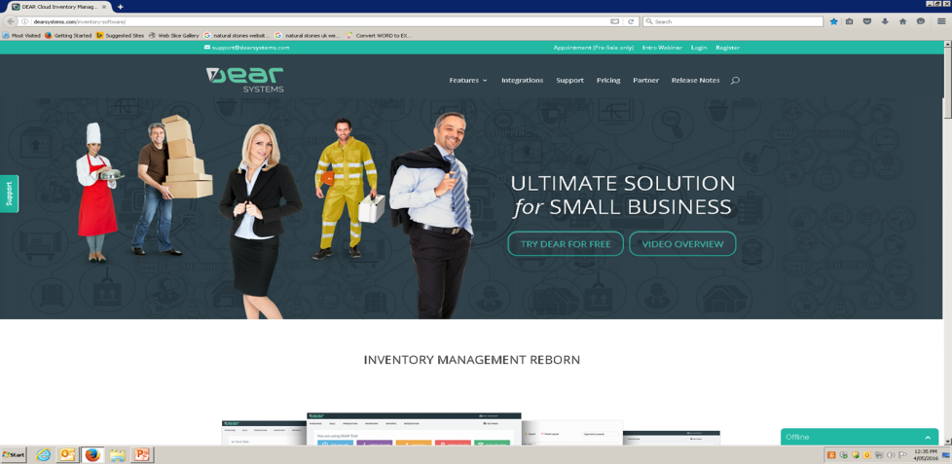
Created by Daniele de Jesus
Section 1: Sales Process (Product)
Start the sales from the quote
Click on “sale”

Click on “new sale”

Type customer name

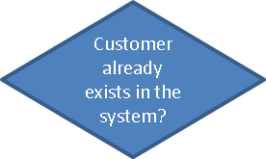
NO
Add new customer with all the details¹ and save it

YES
Select the right option

Type the customer reference

Select the sales rep

Go down and click on “Quote line”

Type the products code

Select the right option and click enter

Type the quantity, price and discount if applicable

Check the tax rule

Change it to “GST on income”
Is the tax rule “GST on income”?
NO

Click on “ additional charge”
Is there any freight charge?
YES

NO
Select “freight charge” (FR01)
Authorise the quote and go to the Order

Type the amount charge
Click on the “order line”

Click on “copy from quote"

Change what is not correct
Is everything the same as the quote?
NO

YES
Click on ”authorise”

Click on “backorder” (INDENT ORDER)
Is there enough qty?
NO

YES
Is there any prepayment against the order?²
Go to “pick”
NO

Click on the “+auto pick”
YES
Go to the quote
Select the right batch number

Click on “ +prepayment”
Check if the location is correct

Select the account # 101

Authorise the pick

Print 2 copies of the pick
Type the reference, the date of payment and amount paid

Fill in the PO request and ask Ledi to raise the PO on the system

Save the quote up on the top
Give the 2 copies to warehouse person

Put together the request form, the SO⁶ and the PO raised by Ledi and ask Werner signature on the PO
Are you in charge of the warehouse?
NO
End of the sale process
YES
YES
Go to “view all” on “Sales”

Type the SO#

Select the right option

Click on “pack”

Click on “+copy from pick”

Check if all the details are correct

Type if the product was delivered or picked up and the date in the “Note”

Authorise the pack

Click on Ship

Click on “+Auto fill”

Click and type the correct date and carrier

Authorise the ship

Write down the SO# details on the in/out sheet

NO
At the end of the day, give the in/out sheet to Ledi
End of the sale³
Are you in charge of the invoicing?

YES
Click on “Invoice”

Type the invoice date

Check if all the details ate correct: qty, price, discount, tax rule
Is everything correct?
NO
Fix the wrong information

YES
Is there any payment against this invoice?

NO
Close the invoice and go back to it when receive the payment

YES
Click on “+additional charge”
Was the payment made by DD, cash or eftpos?

NO

YES
Select the “credit card fee” option (CC01)
Authorise the invoice

Click on “+Payment”
Type the fee amount

Select the account # 101

Type the reference, the date of payment and amount paid

Save the invoice up on the top
End of the sale

Section 2: Sales Process (Service)
Start the process of selling a service
Click on “sale”

Click on “new sale (services only)”

Type customer name

NO
Add new customer with all the details¹ and save it

YES
Select the right option

Type the customer reference

Select the sales rep

Go down and click on “Quote line”

Type the service’s code

Select the right option

Type the quantity, price and discount if applicable

Check the tax rule

Is the tax rule “GST on income”?
Change it to “GST on income”
NO

YES
Authorise the quote²

End of the sale³
Are you in charge of the invoicing?
NO

YES
Click on “Invoice”

Type the invoice date

Check if all the details ate correct: qty, price, discount, tax rule

Is everything correct?
NO
Fix the wrong information

YES
Close the invoice and go back to it when receive the payment
Is there any payment against this invoice?
NO

YES
Was the payment made by DD, cash or eftpos?
NO
Click on “+additional charge”

YES
Select the “credit card fee” option (CC01)
Authorise the invoice

Type the fee amount
Click on “+Payment”

Select the account # 101
Type the reference, the date of payment and amount paid

End of the sale
Save the invoice up on the top

Section 3: Sales Process (Supply and Install)
Start the process of selling a supply and install
Click on “sale”

Click on “new sale”

Type customer name

NO
Add new customer with all the details¹ and save it

YES
Select the right option

Type the customer reference

Select the sales rep

Go down and click on “Quote line”

Type the code SI01

Select the right option from the ones the system provides

Type the quantity (1), price and discount if applicable

Check the tax rule

Is the tax rule “GST on income”?
Change it to “GST on income”
NO

YES
Authorise the quote and go to the Order

Type the amount charge
Click on the “order line”

Click on “copy from quote"

Is everything the same as the quote?
Change what is not correct
NO

YES
Click on ”authorise”

Click on “backorder”

A
End of sale
Have you received any deposit?
Are you allowed to create the FGs?

Go back to the quote
Click on “Reorder backordered stock” on “Purchase”

Click on “ +prepayment”
Select the customer name
Select the account # 101

Go down and click on “Reorder”
Type the reference, the date of payment and amount paid

Click on the FG generated by the system

Was the payment made by DD, cash or eftpos?
NO
Type the two required dates
Type the correct supplied product and its qty
Click on “Undo” and go back to the quote
YES
Click on “+Payment”
Type the Processing’ s price
Click on “+additional charge”
Select the account # 101
Select the “credit card fee” option (CC01)
Authorise the assembly order and go to pick
Type the reference, the date of payment and amount paid
Type the fee amount
Click on “allocate”
Check the batch #, correct it (if needed)
Save the quote up on the top
Authorise the quote

Type the SO#, the customer name and the sales rep on the “notes”

Go back to the SO# when the SI is finished

Click on “pick” and check the FG #
Is the FG correct?

Authorise the pick and go to invoice

Follow the steps as in the pages 6 and 7
End of the process

Section 4: Creating a new code
Start from the smartsheet (SKULIST)

Type the next available number in the related column and the new code and save it
In Dear click on Inventory and “new product”

Copy the new SKU and the product name from the smartsheet

Select the type, category, costing method and unit measure⁴
Complete the other pieces of information⁵

Ask to save the new product

End of the process created

Section 5: Purchase Process
Start the purchase process
Click on “new purchase”

Click on “additional cost”
Is it a PO to buy a product?
NO

YES
Has the supplier invoice been received without a PO?
YES
Click on” Blind receipt” and go strait to “invoice”

NO
Click on “+order line”

Type and select the product/service from the ones the system provides
Type the qty, the price and discount if applicable

Check if the the tax rule is right⁶
Authorise the order
NO
Select “invoice first”
Has the stock been received before the supplier invoice?

YES
Click on “invoice”
Select “stock first”

Click on “ stock received”
Type the qty received and the batch #

Click “authorise”
When receive the supplier invoice, click on “invoice”

Type the supplier invoice# and the date
Check the qty: it needs to be the same as the stock received

Type the price shown on the supplier invoice

Authorise the invoice
What was done first?
When the payment is made, click on “+Payment”
Invoice stock received

Select the account 101

Type the reference, date of payment and the amount paid

Save the purchase up on the top or down on the bottom

End of the purchase process

Stock Adjustment Process

Stock Transfer Process

Notes:
1) You must complete all details the system asks for: client’s full name + street address (+ postal if it differs!); site address (if different from above); name of person in charge of project; all contact details (mobile phones, landlines, email address, website if available);
2) The quote for the service does not need to become a proforma. From the quote you do strait to the invoice;
3) DO NOT apply any payment if it is not for an indent order. Just tell Ledi;
3.1) DO NOT undo any invoice!!! If you need to change something on your sale, please just tell Ledi;
4) Type: is the new item a product/stock or a service?
If it is a product/stock:
Category: marble, travertine, ceramic, limestone, etc.
Unit measure: SQM, PCS, Sheet, etc.
Costing method: always select “special batch”
If it is a service:
Category: freight, customised order, claim, etc
Unit of measure: 1
No costing method
5) Other details:
5.1) Select “No drop ship”
5.2) Inventory account: 630 (stock on hand)
5.3) Revenue account: 200 (sales)
5.4) COGs account: 350 (cost of goods sold)
5.5) Purchase tax rule: GST on expenses if it is purchase from a local supplier; GST free expenses if it is purchase from overseas supplier
5.6) Sales Tax rule: GST on income
5.7) Status: active
5.8) Select default location: Sydney or Melbourne
5.9) Additional attributes set (only if it is a product): select “material specifications”
5.10) Product tags: type the product name again and then type different combinations with parts of the name, always separated by commas
5.11) Click on “additional attributes” and type the finish, size, cut (if applicable), group (tile, slab, etc) and the colour (the same as the brand)
5.12) Click on “prices” and fill in the wholesale, retail and the trade prices.
6) In order to raise a PO for an indent order, the SO needs to be paid for and the payment needs to figure in the SO.

